Question One - Relational Algebra

1. *Translate the following query into Relational Algebra:*
2. **Retrieve the names of all manufactures who produce some products of category food or ‘healthcare’.**

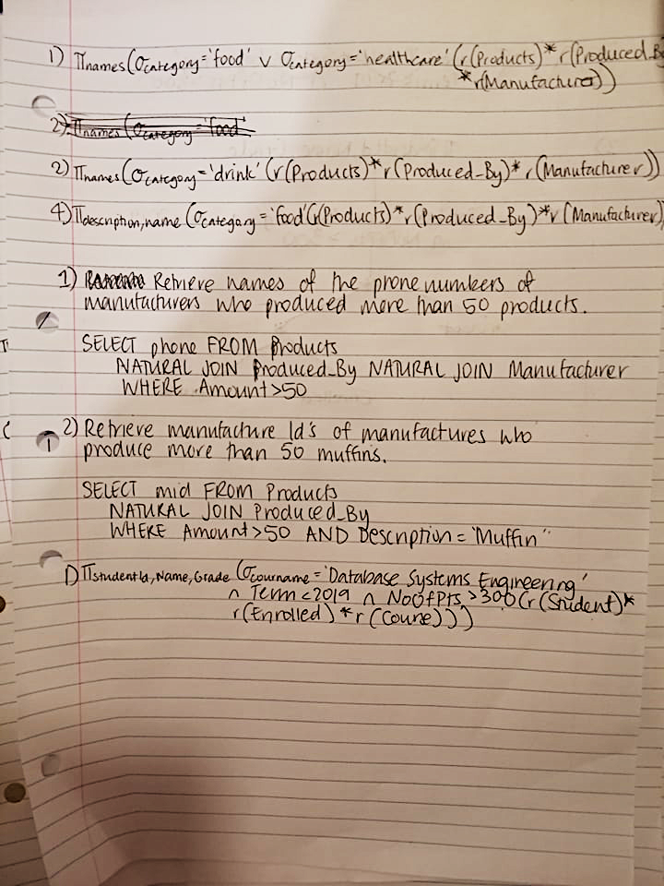

1. **Retrieve the names of all manufacturers who always produce products of category ‘drink’.**

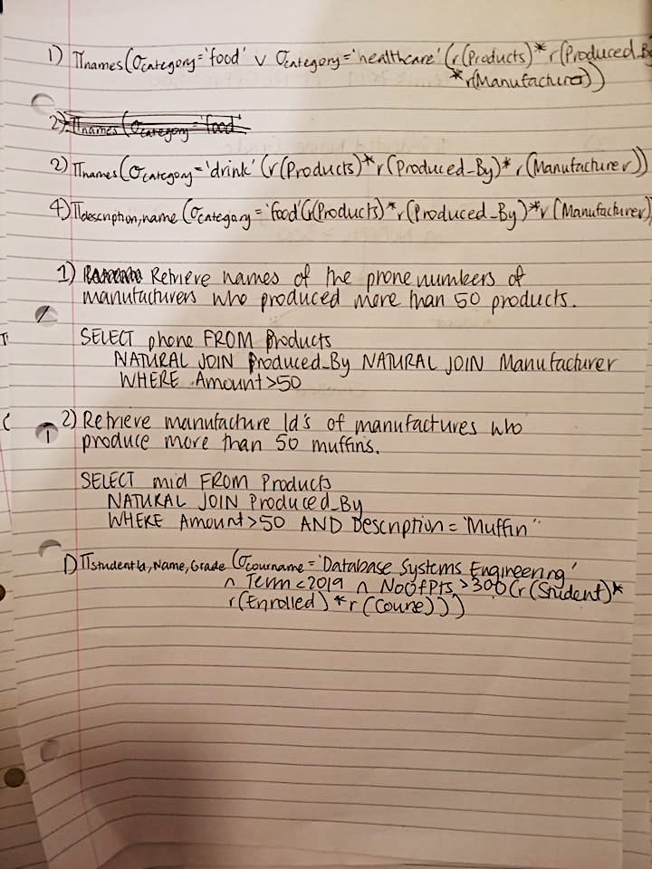

1. **Retrieve the descriptions of all products that are produced by two or more manufacturers.**
2. **For all products of category ‘food’ list their descriptions and the names of their manufacturers.**
3. *Translate the following two queries into plain English and into SQL:*
4. **πPhone (r(Products) * (σAmount>50 (r(Produced_By))) * r(Manufacturer))**



1. **πMId (σAmount>50 (r(Produced_By))) ∩ πMId (r(Produced_By) * (σDescription=’Muffin’ (r(Products))))**



Question Two – Heuristic and Cost-Based Query Optimization

1. *Heuristic query optimisation*
2. **Transfer the above given query into Relational Algebra.**



1. **Draw a query tree corresponding to your answer to sub question 1)** 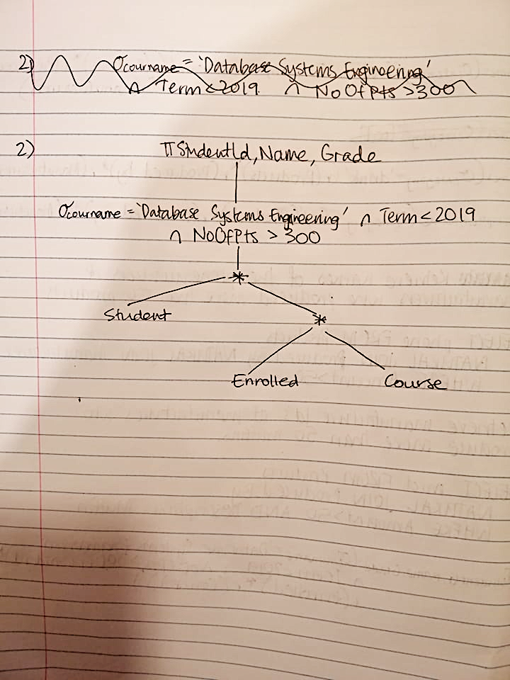
2. **Transfer the query tree from 2) into an optimized query tree using the query optimization heuristics.**

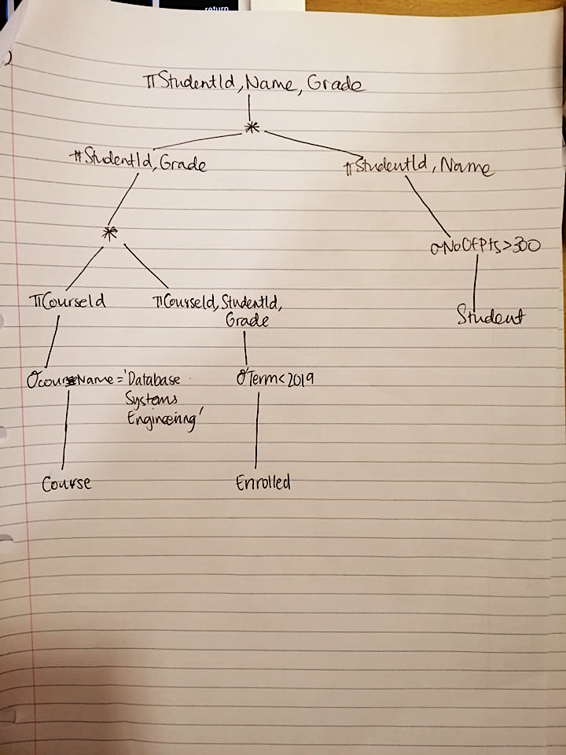

1. *Query cost calculation*
2. **For the given query below, draw a query tree and calculate the cost of executing the query.**

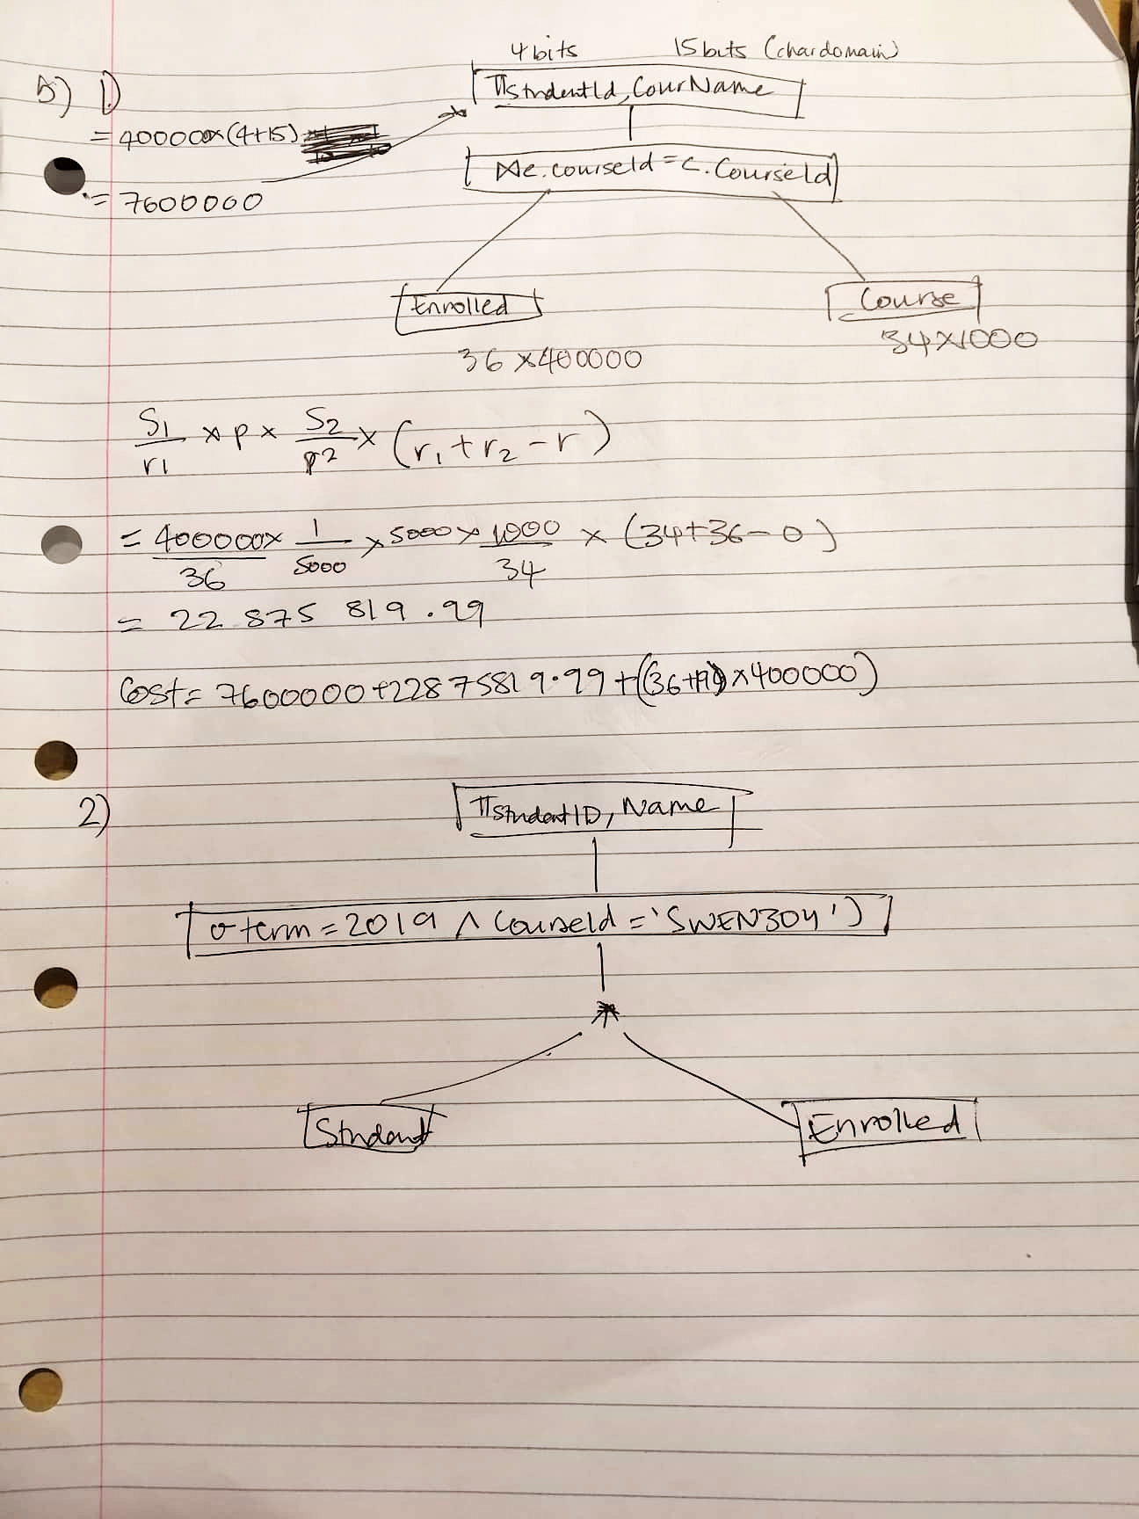

1. **For the given query below, draw a query tree and calculate the cost of executing query.**





Question Three – PostgreSQL and Query Optimization

1. **.**
2. The original query gave this response: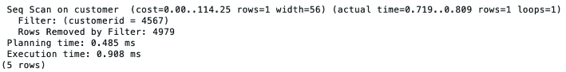

I fixed this by using this query:

CREATE INDEX seach_customerID ON customer(customerID);  
CREATE INDEX  
EXPLAIN ANALYZE select l_name, f_name from customer where cutomerid = 4567;   
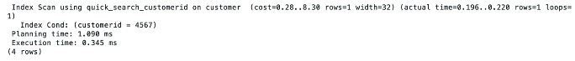

By using this query it decreased my execution time as the index is smaller than an entire table and therefore will take less time to search through. (ref. <https://solutioncenter.apexsql.com/how-to-create-and-optimize-sql-server-indexes-for-better-performance/>).